EDI Communication Form Freight invoices

Send this form by e-mail to: edi.rollout@volvo.com
Please state the following in the subject: EDI Com form Freight INVOIC, [your carrier id]

Please chose which communication protocol (OFTP2 or AS2) you will be using and fill the form accordingly.

 | Volvo Group | Communication partner
 |  | Volvo's ID on carrier (carrier No)
Company Name | Volvo Information Technology | Company name
Address | S-405 08 Gothenburg | Address
 | Sweden
Stand-by | 00-24
Test contact:  Production contact: | EDI & Business Integration Services  Volvo Information Technology  edi.rollout@volvo.com  HCL Technologies Ltd.  +46 31 66 22 00  www.volvogroup.com/edi (service request web form) | Communication Contact
Phone no
E-mail

 |  | Financial contact
Phone no
E-mail

OFTP2 - Odette File Transfer Protocol

TCP/IP | Volvo Group | Communication partner
TCP/IP Physical address SSID | O0942000055610326980VOLVO | SSID
TCP/IP SFID | O0942000055610326980VOLVO | SFID
TCP/IP Network address | oftp2.volvo.com | Network address
TCP Port | 6619 | 6619
TCP/IP Password | VOLOFTP2 | Password
TLS SSL Certificate CA | Sectigo | Certificate Authority
Firewall details
N.B. Incoming and outgoing IP-addresses are different because of HW (cluster) solutions. Identity sending files from Volvo 192.138.117.2 or 192.138.117.25. If possible configure your firewalls to accept files from 192.138.117*

SSL Certificate details:
You need a SSL Certificate issued by an approved Certificate Authority (CA). See list of approved CA at http://www.edi.volvogroup.com/en-en/setup-edi/edi-communication-setup.html

N.B. please make sure to add the domain host name in the certificate request and do not use a static IP as host name.

Make sure you have the Root CA Certificate of Sectigo imported in your EDI System. This will be used to verify Volvo's certificate.
Root for Standard SSL can be found at:
https://support.sectigo.com/articles/Knowledge/Sectigo-Intermediate-Certificates (Download SHA-2 Root: USERTrust RSA Certification Authority)
If necessary; also import the intermediate certificate found at:
https://support.sectigo.com/articles/Knowledge/Sectigo-Intermediate-Certificates (Download Sectigo RSA Organization Validation Secure Server CA [ Intermediate ] )

AS2 Communication Form

AS2 parameter | Volvo Group | Communication partner
AS2 Identifier | VOLVO353952559AS2 | AS2 ID
AS2 MDN URL | https://as2.volvo.com:8443/SeeburgerAS2/AS2Controller?ls=001 | AS2 MDN URL
AS2 URL | https://as2.volvo.com:8443/SeeburgerAS2/AS2Controller?ls=001 | AS2 URL
Message/MDN Transport | HTTPS | HTTPS
TLS SSL Certificate CA | Sectigo | Certificate Authority
MDN handling (Asynchronous/Synchronous) | Asynchronous or Synchronous | Asynchronous/Synchronous
Signed MDN (Y/N)* | Y or N (N by default) | Y/N
Signature (Y/N)* | Y or N (N by default) | Y/N
Encryption (Y/N)* | Y or N (N by default) | Y/N
Signed MDN/Signature/Encryption* used only in Secure scenario
If you want to use encryption and/or sign, we will need your certificate to encrypt files with and your certificate to verify your signature. We will then provide you with the certificate that is used by us for signing and should be used by you to encrypt the files sent to us.
Available Signature digest algorithm: MD5, SHA-1, SHA-224, SHA-256, SHA-384, SHA-512
Available Encryption algorithms (recommended is 3DES or AES/256): 3DES, AES/128, AES/192, AES/256, RC2/128, RC2/40, RC2/64

Firewall details
N.B. Incoming and outgoing IP-addresses are different because of HW (cluster) solutions. Identity sending files from Volvo 192.138.117.2 or 192.138.117.25. If possible configure your firewalls to accept files from 192.138.117*

SSL Certificate details
You need a SSL Certificate issued by an approved Certificate Authority (CA). See list of approved CA at http://www.edi.volvogroup.com/en-en/setup-edi/edi-communication-setup.html#as2 N.B. please make sure to add the domain host name in the certificate request and do not use a static IP as host name.

Volvo only supports a push scenario. Files must be pushed from AS2 client to AS2 server. Polling files not allowed.

Authentication policy
Volvo support server authentication by verifying CA's (certificate authorities) as trust model. If server certificate has been verified by trusted CA, Volvo will trust the server.

Volvo does not use/require client authentication. Volvo uses TLS line security (session encryption only).

Session authentication should be done with AS2ID.

Volvo support both data encryption and data signatures in message security layer, but see scenario recommendations in the table below.

Volvo is using differentiated authentication policies for AS2. The differentiated authentication policies depend on the scenario to be used.

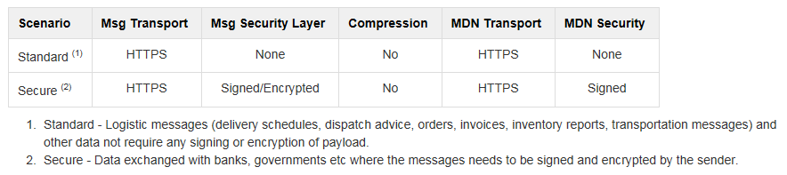

Note! The code representation will be ASCII and the record length will be Unstructured. Please notify us if you want another code representation and/or record length.

Please fill in regardless if OFTP2 or AS2 will be used:

Technical details: |  | Communication partner
Logical address* | UNB 0004/0010
Qualifier* | UNB 0007
Internal address | UNB 0008/0014
* Mandatory

Global invoice message D03A to be transferred to the following customers
Legal buyer: Volvo Logistics Corporation (1705)
Volvo’s  customer No | Customer name | Logical address | Qual | Internal address | Requested
1705 | Volvo Logistics Corporation, Gothenburg | 094200005561979732 | 30 | 001705

Only for GXS customers (note that the only logical address allowed for Volvo is OD).
1705 | Volvo Logistics Corporation, Gothenburg | 094200005561979732000001 | OD

