AS2 EDI Communication form

Contact info | Volvo Group | Communication partner
ID |  | Volvo’s ID on supplier
Company name | Volvo Information Technology | Company name
Address | S-405 08 Gothenburg | Address
City | GOTHENBURG | City
Country | Sweden | Country
Stand-by | 00-24 | Stand-by
Test Contact | EDI & Business Integration Services  Volvo Information Technology  edi.rollout@volvo.com | Name, email, phone
Production Contact | HCL Technologies Ltd.  +46 31 66 22 00 | Name
Email | www.volvogroup.com/edi (service request web form) | Email
Phone | +46 31 66 22 00 | Phone

AS2 parameter | Volvo Group | Communication partner
AS2 Identifier | VOLVO353952559AS2 | AS2 ID
AS2 MDN URL | https://as2.volvo.com:8443/SeeburgerAS2/AS2Controller?ls=001 | AS2 MDN URL
AS2 URL | https://as2.volvo.com:8443/SeeburgerAS2/AS2Controller?ls=001 | AS2 URL
Message/MDN Transport | HTTPS | HTTPS
TLS SSL Certificate CA | Sectigo | Certificate Authority
MDN handling (Synchronous) | Synchronous | Synchronous
SECURE SCENARIO | ONLY | NOT STANDARD EDI
Signed MDN (Y/N)* | Y or N (N by default) | Y/N
Signature (Y/N)* | Y or N (N by default) | Y/N
Encryption (Y/N)* | Y or N (N by default) | Y/N
Signed MDN/Signature/Encryption* used only in Secure scenario
If you want to use encryption and/or sign, we will need your certificate to encrypt files with and your certificate to verify your signature. We will then provide you with the certificate that is used by us for signing and should be used by you to encrypt the files sent to us.
Available Signature digest algorithm: MD5, SHA-1, SHA-224, SHA-256, SHA-384, SHA-512
Available Encryption algorithms (recommended is 3DES or AES/256): 3DES, AES/128, AES/192, AES/256, RC2/128, RC2/40, RC2/64

Secure scenario is not allowed for standard EDI i.e. logistic messages.

Firewall details
N.B. Incoming and outgoing IP-addresses are different because of HW (cluster) solutions. Identity sending files from Volvo 192.138.117.2 or 192.138.117.25. If possible configure your firewalls to accept files from 192.138.117*

SSL Certificate details
You need a SSL Certificate issued by an approved Certificate Authority (CA). See list of approved CA at http://www.edi.volvogroup.com/en-en/setup-edi/edi-communication-setup.html
N.B. please make sure to add the domain host name in the certificate request and do not use a static IP as host name.
Volvo only supports a push scenario. Files must be pushed from AS2 client to AS2 server. Polling files not allowed.

Authentication policy
Volvo support server authentication by verifying CA's (certificate authorities) as trust model. If server certificate has been verified by trusted CA, Volvo will trust the server.

Volvo does not use/require client authentication. Volvo uses TLS line security (session encryption only).

Root for Standard SSL can be found at:
https://support.sectigo.com/articles/Knowledge/Sectigo-Intermediate-Certificates (Download SHA-2 Root: USERTrust RSA Certification Authority)
If necessary; also import the intermediate certificate found at:
https://support.sectigo.com/articles/Knowledge/Sectigo-Intermediate-Certificates (Download Sectigo RSA Organization Validation Secure Server CA [ Intermediate ] )

Session authentication should be done with AS2ID.

Volvo support both data encryption and data signatures in message security layer, but see scenario recommendations in the table below.

Volvo is using differentiated authentication policies for AS2. The differentiated authentication policies depend on the scenario to be used.

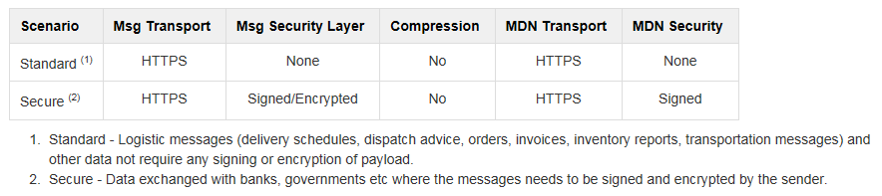

Note! The code representation will be ASCII and the record length will be Unstructured. Please notify us if you want another code representation and/or record length.
UNB-address: |  | Communication partner
Logical address | UNB 0004/0010
Qualifier | UNB 0007 | 30
Internal address | UNB 0008/0014
Virtual filename
Volvo does not normally use predefined virtual filenames. If this is requested, please fill out the virtual filename you wish to receive.
File format
The file format will be Unstructured. Please notify us if you want any other file format.
Code representation
The code representation will be ASCII. Please notify us if you want any other code representation.

